Audience Loyalty Measurement in the Entertainment Sector
Pooja Joshi & E.Code [E25007]

Overview :
The main focus of this task is to measure audience loyalty in the entertainment sector. The analysis involves calculating a loyalty score based on engagement metrics such as attendance count and content diversity, which reflects how widely audiences engage with different types of content.

Objective:

· Develop a loyalty score based on audience engagement with different media types and content.
· Measure and visualize loyalty over time by analyzing audience engagement patterns

Assigned Task(s) :

- Task 1: Create a loyalty_score column by using attendance and content diversity metrics.
- Task 2: Segment the audience by media type and content diversity.
- Task 3: Visualize loyalty trends over time.

Task Details
· Task 1: Calculated loyalty_score by combining attendance_count and content_diversity using the formula: loyalty_score = attendance_count×(1+content_diversity_weight×content_diversity)\text{loyalty\_score} = \text{attendance\_count} \times \left(1 + \text{content\_diversity\_weight} \times \text{content\_diversity}\right)loyalty_score=attendance_count×(1+content_diversity_weight×content_diversity)
- Status: Completed
- Details: Implemented the calculation of a loyalty_score using the provided dataset. Normalized engagement levels and added a content diversity weight to reflect audience interaction with different types of content.

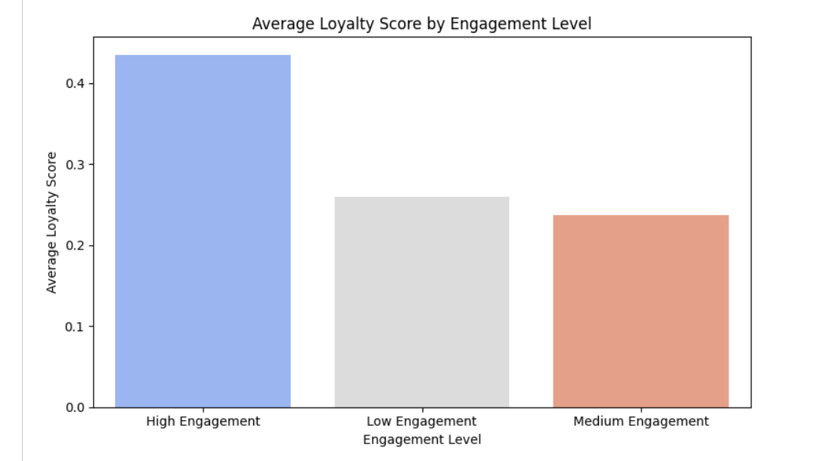
·

Task 2: Segmented audience based on media_type and calculated aggregate loyalty scores by each segment.
- Status: Completed
- Details: Grouped the dataset by media_type and calculated total attendance and average loyalty score for each media type.
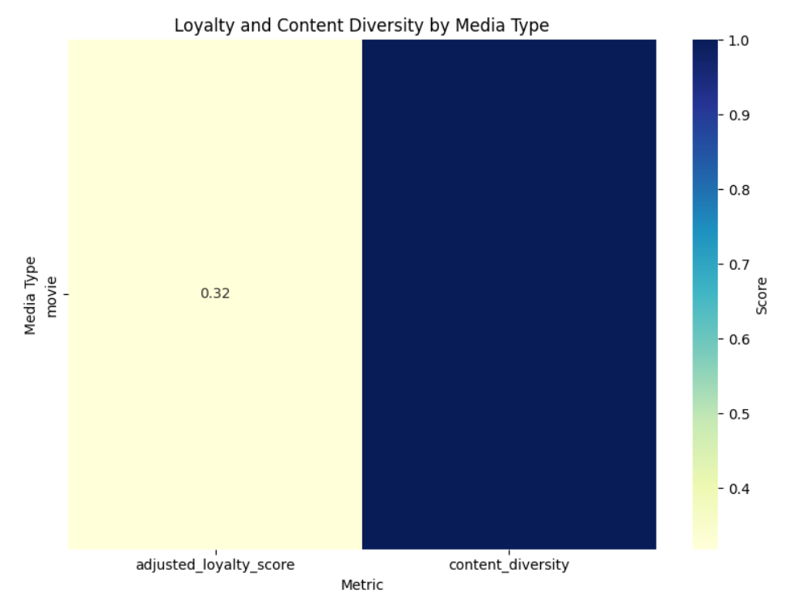
· Task 3: Visualized loyalty trends over time.
- Status: Completed
- Details: Plotted loyalty scores over time, showing how audience engagement and loyalty fluctuate based on the release year.
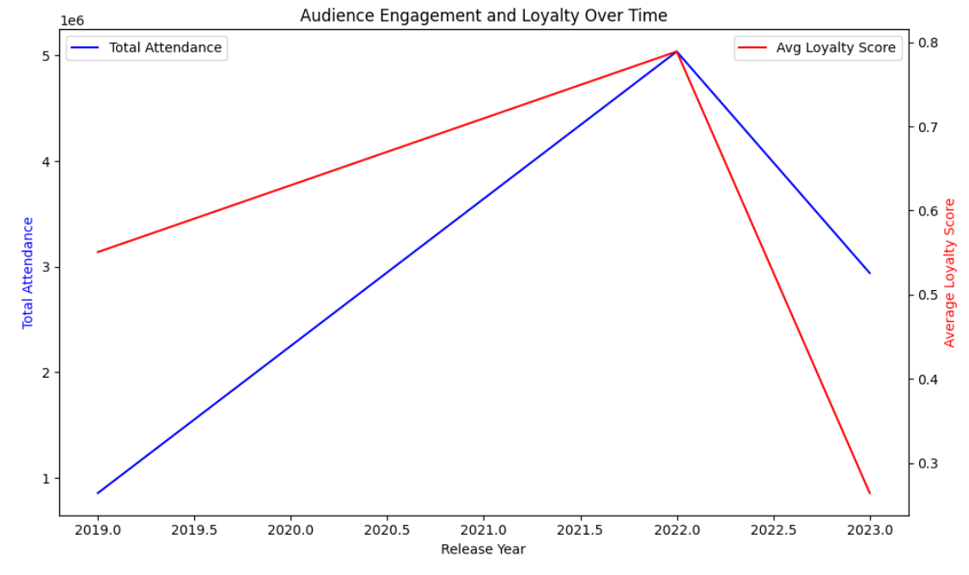

Progress :

· Accomplishments:
- Successfully calculated loyalty scores and visualized trends over time.
- Identified key patterns in audience engagement based on media type and release year.
· Metrics:
· Total number of audience interactions analyzed: 11,198,027
· Average loyalty score per media type:
- Movie: 945.38
- TV: Not available
- Unknown: Not available

Challenges and Solutions :

- Challenges Faced:
  - Data inconsistencies in some columns, such as missing values in media_type.

- Solutions Implemented:
  - Handled missing values in media_type by assigning a default category "unknown". Normalized the dataset before calculating scores.

Next Steps :

· Upcoming Tasks:
- Further refine the loyalty score calculation by introducing demographic factors if data is available.
Goals:
- Investigate deeper segmentation based on content genres and specific user demographics to improve the audience loyalty model.

Conclusion :

Summary: In conclusion, we developed a robust audience loyalty score using a combination of engagement metrics and content diversity. These insights can guide content strategies in the entertainment sector by identifying the most loyal audiences. The next steps involve refining the model with more detailed audience segmentation and analyzing genre-specific loyalty trends.

Acknowledgments: Thank the audience for their time and attention.

Instructions:
- Use Google Docs. Single Column
- TNR stands for Times New Roman: B - Bold
- Use images as required with proper references
- Use charts, tables as per your requirement.
- Number of Pages: 2 to 8 for each task report.

